Privacy Preserving Blockchain & ML Hybrid System for Adaptive Financial Fraud Detection

Abstract
With the exponential rise in digital financial transactions, the threat of fraudulent activities has grown more sophisticated and pervasive. Traditional fraud detection systems, which rely heavily on centralized machine learning (ML) models, are increasingly vulnerable to data tampering and cyberattacks. A compromised database can significantly degrade the performance of ML algorithms, leading to incorrect predictions and enabling malicious transactions to slip through undetected. To address these limitations, this research introduces an innovative approach that combines Blockchain technology with incremental machine learning to build a privacy-preserving and tamper-proof fraud detection system. The system ensures that trained ML model weights are securely stored on the blockchain, making unauthorized alterations virtually impossible due to the cryptographic hashing and immutability inherent in blockchain architecture.
This framework employs multiple machine learning algorithms such as Passive Aggressive Classifier (PAC), Stochastic Gradient Descent (SGD), Perceptron, and Naïve Bayes, each trained incrementally on large-scale transactional data. Training is split across two difficulty levels—Level 1 (10,000 records) and Level 2 (30,000 records)—to evaluate the adaptability and time efficiency of each model. To handle data imbalance, the SMOTE technique is used for oversampling. The best-performing model (SGD with 99.83% accuracy) is selected based on metrics like accuracy, precision, recall, and F-score, and its learned weights are stored securely on the Ethereum blockchain using a smart contract written in Solidity. This contract allows for decentralized and secure storage of model weights, making them retrievable by any authorized organization for real-time prediction.
Incentives for blockchain mining are managed dynamically based on data difficulty levels to reduce computational delays. A user-friendly Flask web application is also implemented for administrators to upload transaction data and view fraud predictions in real-time. This combination of machine learning, blockchain, and smart contracts provides a scalable, tamper-proof, and adaptive solution for next-generation fraud detection systems.
Keywords: Fraud Detection, Blockchain, Incremental Machine Learning, Privacy-Preserving, Tamper-Proof, Passive Aggressive Classifier, Stochastic Gradient Descent, Naïve Bayes, SMOTE, Smart Contracts.
Existing system
The existing fraud detection systems rely on centralized servers to train and store ML models. These systems are vulnerable to tampering by insiders or attackers with database access. Predictions made by such compromised systems can misclassify fraudulent transactions as legitimate, leading to severe financial losses.
Disadvantages:
- Centralized architecture allows for undetected tampering of the database.
- No mechanism to verify model training history or integrity.
- Static model training with
Proposed system
The proposed system uses Blockchain technology to store machine learning model weights in a tamper-proof, decentralized manner. It trains multiple ML models incrementally and stores the most accurate model’s weights using Ethereum smart contracts. Predictions are then made using the blockchain-secured model, ensuring both accuracy and data integrity.
Advantages:
- Blockchain ensures tamper-proof storage of model weights and predictions.
- Smart contracts enable secure sharing and updating of models.
- Incentive-based mining rewards efforts based on difficulty level.
Modules Description:
To implement this project we have designed following modules
- Data Loading Module – Loads and displays the transaction dataset for processing.
- Data Preprocessing Module – Applies label encoding, normalization, and SMOTE to clean and balance the dataset.
- Difficulty Level Split Module – Splits dataset into smaller chunks for incremental learning.
- Model Training Module – Trains ML algorithms like PAC, SGD, Perceptron, and Naïve Bayes incrementally.
- Performance Evaluation Module – Calculates accuracy, precision, recall, and F-score for all models.
- Blockchain Connection Module – Connects Python backend to Ethereum blockchain using smart contracts.
- Model Weight Storage Module – Saves the best-performing model weights to blockchain with metadata.
- Flask Web Interface Module – Offers user interface for admin login, fraud prediction, and dataset upload.
- Smart Contract Deployment Module – Deploys Solidity-based contract to Ethereum to store and manage model data.
- Fraud Prediction Module – Accepts test data and returns predicted label (Normal/Fraud) using best model from blockchain.

System Architecture:
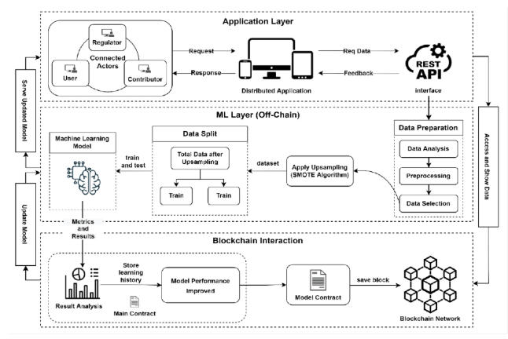
HARDWARE & SOFTWARE REQUIREMENTS:
HARDWARE REQUIRMENTS:
- Processor : Intel I3 (min)
- Hard Disk : 500 GB (min).
- Ram : 4 GB (min).
SOFTWARE REQUIRMENTS:
- Operating system : Windows 10 (min)
- Coding Language : python (3.7.0)

